**The discovery of cells**

1. **Read and summarise the information below:**

In the seventeenth century, Robert Hooke looked at thin slices of cork under a microscope that he had made himself from lenses. He observed small box-like shapes inside the cork. He called the little boxes that he saw cells. Using microscopes to carefully observe different living things showed that they were all made up of cells. Observations also showed that many of these cells shared common features, such as the presence of a structure called the nucleus. Some organisms were made up of a single cell (unicellular), whereas others were made up of many cells (multicellular).

**Summary:**

**DEVELOPMENT OF THE MICROSCOPE TIMELINE**



1. **Using the information in the time line’s above write in the correct name of the scientist next to the appropriate discovery or contribution**

**SCIENTIST DISCOVERY OR CONTRIBUTION**

|  |  |
| --- | --- |
|  | built the first electron microscope |
|  | proposed that all plants are made up of cells |
|  | proposed that all animals are made up of cells |
|  | proposed that all cells arise from cells that already exist |
|  | used the term cells to describe a structure found in plant cells |
|  | used the term nucleus to describe a structure found in plant cells |

**Little, littler, littlest . . .**

In the microscopic world, there is often a need to describe things in much smaller terms than the units of measurement that you already know, such as metre, centimetre and millimetre. In describing cells, other units of measurement, such as micrometre (μm, also called micron) and nanometre (nm), are often used.

See diagram on next page:



1. **Complete the following questions**
2. Identify two units of measurement often used when describing cells.

1. What are four things that can be seen with an electron microscope:­

four things with a light microscope:

two things with both

**Focusing on a small world**

Just because you can’t see something doesn’t mean that it’s not there. Microscopes can be used to make small objects appear bigger, so that we can see what was previously invisible to us.

**Types of microscopes**

The two main types of microscopes are light microscopes and electron microscopes. **Light** **microscopes** use light rays whereas **electron** **microscopes** use small particles called electrons.

1. **Label components of a light microscope**

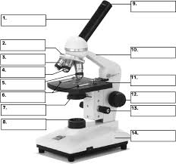

1. **a) Write the steps for focusing a microscope**

1. **Focus on the samples given. Show your teacher. Complete the table below.**

|  |  |  |
| --- | --- | --- |
| **Sample** | **Focused: Yes or No** | **Teacher Sign Off** |
|  |  |  |
|  |  |  |
|  |  |  |

1. **Magnification:** How many times larger the image of the specimen in compared to the actual size of the specimen.

**Total Magnification = Magnification of Objective X Magnification of ocular**

Fill in the table below

|  |  |  |
| --- | --- | --- |
| Ocular Lens magnification | Objective Lens magnification | Total Magnification |
|  |  |  |
|  |  |  |
|  |  |  |

1. **Follow the steps below on how to correctly draw your biological images**
2. Draw a circle about the size of the base of a water bottle
3. Divide the circle into quadrants (4 sections)
4. Draw what you see in each quadrant (not what you think should be there)
5. Start with the overall outline of what you see
6. Now go in and add detail

*Do not sketch or shade your drawings.*

1. All drawings should be titled and the total magnification of the drawing must be beside the circle i.e. 40 x

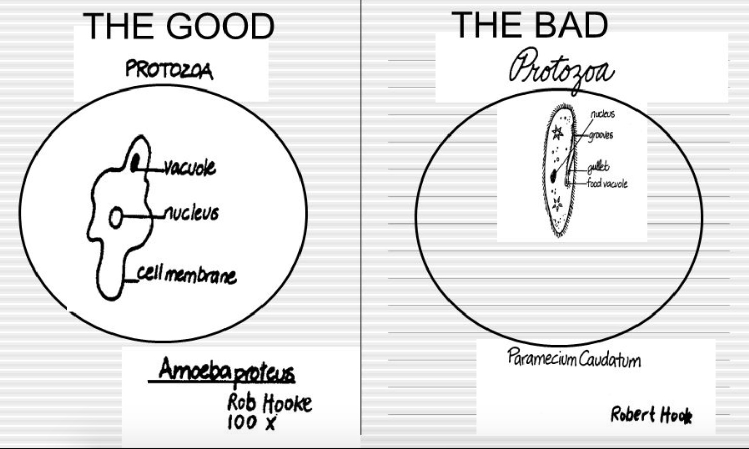

1. **What makes a drawing good? What makes a drawing bad?**

Good:___________________________________________________________________________________________________________________________________________________________________________________________________________________________________________________________________

Bad:____________________________________________________________________________________________________________________________________________________________________________________________________________________________________________________________________

**Your Drawings**

Using the method above create TWO drawings of any slides under different magnifications.

|  |  |
| --- | --- |
| Drawing 1 | Drawing 2 |

**The 5 Second Rule Investigation**

How many times have you dropped food you were about to eat on the floor, shouted “5 second rule”, picked up the food and continued to eat it. This urban myth is the accepted routine for many people. Little thought is given to what could be transferred from the ground to the food you proceed to eat.

Bacteria are all around us – in the air we breathe, the money we touch, hand rails, computer keyboards and of course the ground.

How long does food have to stay on the ground before it becomes contaminated with bacteria?

1. **How would you identity the variables of this experiment?**

**___________________________________________________________________________________________________________________________________________________________________________________________________________________________________________________________________________________________________________________________________________________________________________________________________________________________________________________**

1. **How would you write and aim and hypothesis for this experiment?**

**___________________________________________________________________________________________________________________________________________________________________________________________________________________________________________________________________________________________________________________________________________________________________________________________________________________________________________________**

1. **Materials**

1. **Method**
2. Without opening the agar plates, label the lids of three agar plates with the selected time frame and the fourth one as untouched.
3. Use the sterile forceps to place the gummy bear on the floor for the given time.
4. Use the forceps to pick up the gummy bear.
5. Open the lid of the agar plate just enough to let the gummy bear and forceps through and try not to breathe over the dish.
6. Gently wipe the gummy bear over the entire surface of the agar.
7. Close the lid and sticky tape the agar plate closed.
8. Repeat this procedure for all time frames and give the dishes to your teacher for incubation.
9. Examine the agar plate 24 hours later and record your observations.
10. Do not remove open the agar plates at any time.
11. **Results** –

**In the spaces provided draw the results of your experiment**

|  |  |
| --- | --- |
| Dish 1 | Dish 2 |
| Dish 3 | Dish 4 |

**Complete the table below describing the appearance of your bacteria colonies.**

|  |  |  |  |
| --- | --- | --- | --- |
| **Time** | **Size**  **(mm)** | **Colour** | **Texture**  **(hairy or smooth)** |
| 0 seconds |  |  |  |
|  |  |  |  |
|  |  |  |  |
| Untouched agar dish |  |  |  |

**Do you think the bacteria you collected is harmful? Why/why not?**

**____________________________________________________________________________________________________________________________________________________________________________________________________________________________________________________________________________________________________________________________________________________________**

1. **a) Why did we test an untouched agar plate and a gummy bear that hadn’t been touched on the floor?**

**____________________________________________________________________________________________________________________________________________________________________________________________________________________________________________________________________________________________________________________________________________________________**

**b) Was this experiment reliable and valid? Explain why you think this.**

**____________________________________________________________________________________________________________________________________________________________________________________________________________________________________________________________________________________________________________________________________________________________**

|  |  |  |  |
| --- | --- | --- | --- |
| Question checklist | Tick | Question checklist | Tick |
| 1 |  | 7 |  |
| 2 |  | 8 |  |
| 3 |  | 9 |  |
| 4 |  | 10 |  |
| 5 |  | 11 |  |
| 6 |  | 12 |  |
| 7 |  |  | |